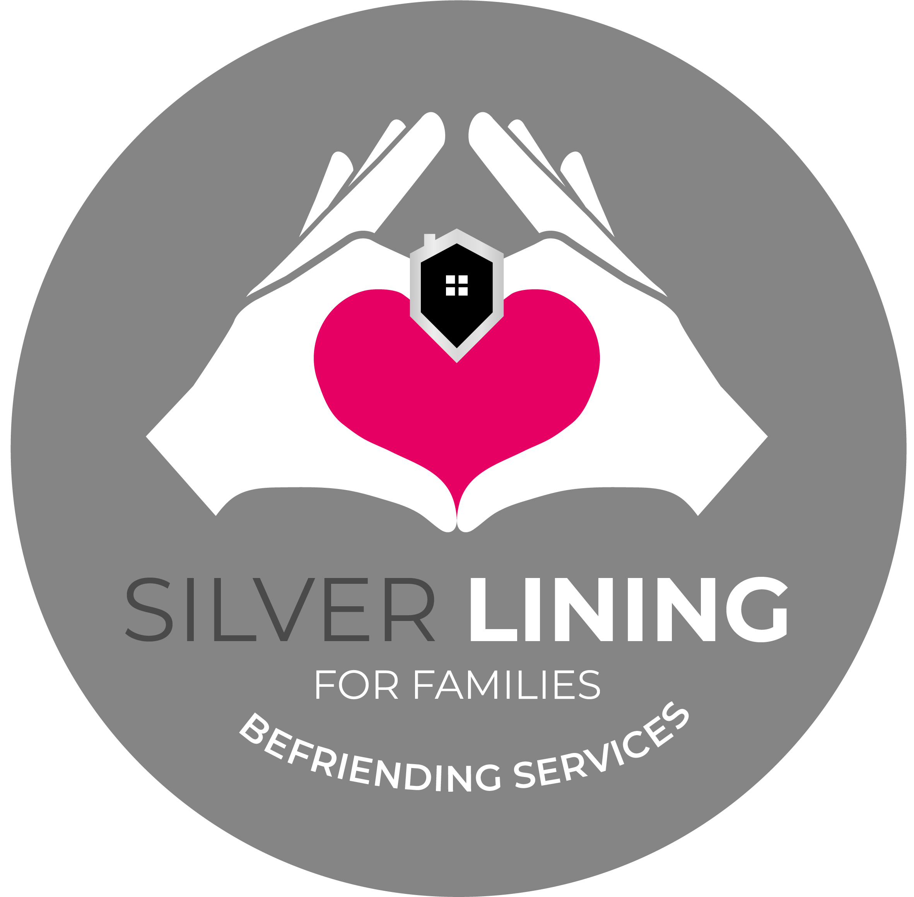
Befriender/ Community Support Worker - Person Specification

Category | Essential Qualities | Desirable Qualities | Method of Assessment
Qualification & Training | - SVQ 2 / SCQF Level 6 Health and Social care, Ability to complete within 5 years.  - SSSC registered or willing and able to register within the required timescales.  - Willingness to complete induction training and ongoing development.  - Understanding of safeguarding responsibilities or willingness to learn.  - Commitment to person centred care principles. | - Training or certificates in Health & Social Care, Mental Health, or Community Support. | - Application Form  - Qualification Certificate
Experience | - Experience working with individuals living with dementia  - Experience building positive, trusting relationships (professional or personal).  - Experience supporting people who are lonely, isolated, or vulnerable (informal or voluntary). | - Experience in befriending, support work, or volunteering.  - Experience working with adults with additional needs.  - Experience helping individuals engage in social or community activities. | - Application Form.  - To evidence at Interview
Skills and Abilities | - Excellent communication and active listening skills.  - Ability to engage people in conversation and meaningful activities.  - Able to provide warm, empathetic, person-centered companionship.  - Ability to encourage independence and confidence.  - Good observational skills to identify changes in wellbeing.  - Able to complete accurate visit notes and follow procedures.  - Ability to support with practical tasks (light cleaning, organising items).  - Ability to undertake a physically active role, including walking and standing for extended periods, carrying shopping, pushing wheelchairs, transporting mobility equipment, and supporting individuals with mobility in line with training, risk assessments, and support plans. Applicants should be able to safely meet the physical demands of the role while promoting independence, dignity, and wellbeing.  - Ability to plan local outings, appointments, or community activities.  - Understanding of professional boundaries and confidentiality.  - Ability to gently motivate and encourage individuals. |  | - Application Form.  - To evidence at interview.  - References for verification.
Personal Qualities | - Kind, compassionate, and caring nature.  - Patient, calm, and emotionally resilient.  - Reliable and consistent in attendance.  - Respectful of dignity, independence, and personal boundaries.  - Non-judgmental with commitment to equality and diversity.  - Honest, trustworthy, and values driven.  - Positive and encouraging approach.  - Ability to build supportive relationships with families as well as service users. | - Previous experience within the care sector, particularly supporting older adults | - Application Form.  - To evidence at interview.  - References for verification.
Knowledge | - Understanding of loneliness, social isolation, and their impact on wellbeing.  - Awareness of confidentiality, boundaries, and safeguarding  - Understanding of challenges faced by unpaid carers and families.  - Awareness of civil rights and privacy protections for adults. | - Knowledge of local community resources. | - Application Form.  - To evidence at interview.
Values & Behavioral Expectations | - Commitment to dignity, respect, and independence.  - Person-centered approach to every interaction.  - Passion for reducing loneliness and improving quality of life.  - Respect for confidentiality and privacy.  - Integrity, professionalism, and reliability. |  | - Application Form.  - To evidence at interview.
Other Requirements | - Ability to use technology – mobile, outlook and other app’s  - Full driving licence with access to a suitable vehicle (capable of accommodating mobility aids/wheelchair)  - Willingness to work in homes and community settings.  - Willing to undergo PVG checks, references, and safe recruitment procedures  - Business insurance is required |  | - To evidence at Interview

